ASSINGMENT 29-01-2026 Lab Assignment 5.4 [PORIKA CHARAN 2303A51570-BATCH-09]

CODE: 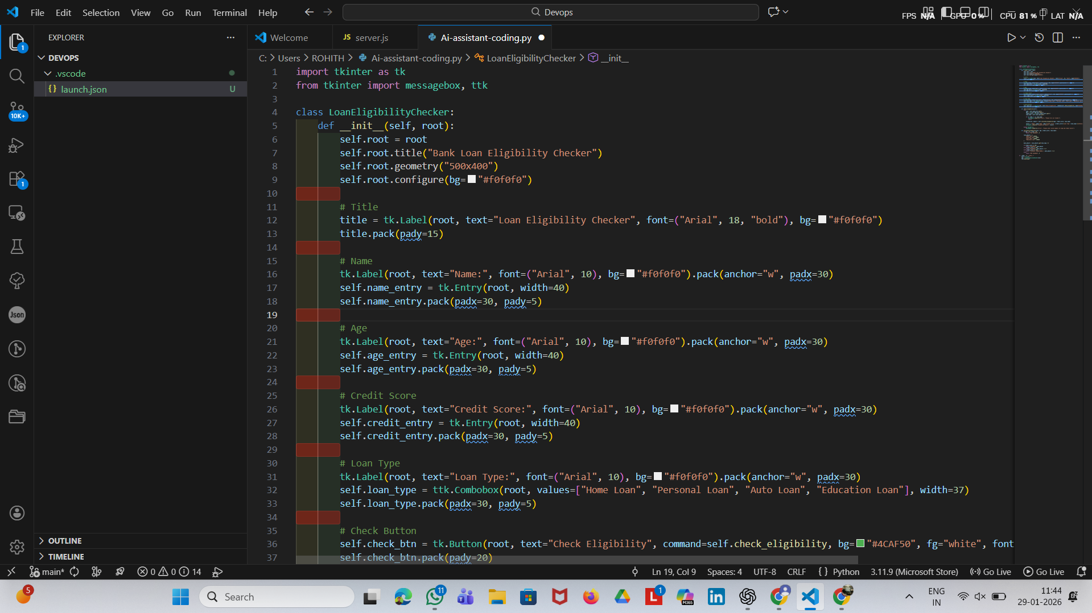
PROMT:#CREATE A BANK LOAN ELIGIBILITY CHECKER GUI APPLICATION WHICH TAKES USER INPUTS AND DISPLAYS ELIGIBILITY STATUS AND LOAN AMOUNT
# BASED ON CERTAIN CRITERIA SCORE ,AGE LIMIT AND LOAN TYPE

import tkinter as tk
from tkinter import messagebox, ttk
from datetime import datetime

class LoanEligibilityChecker:
def __init__(self, root):
self.root = root
self.root.title("Bank Loan Eligibility Checker")
self.root.geometry("500x400")
self.root.configure(bg="#f0f0f0")

# Title
title = tk.Label(root, text="Loan Eligibility Checker", font=("Arial", 18, "bold"), bg="#f0f0f0")
title.pack(pady=15)

# Name
tk.Label(root, text="Name:", font=("Arial", 10), bg="#f0f0f0").pack(anchor="w", padx=30)
self.name_entry = tk.Entry(root, width=40)
self.name_entry.pack(padx=30, pady=5)

# Age
tk.Label(root, text="Age:", font=("Arial", 10), bg="#f0f0f0").pack(anchor="w", padx=30)
self.age_entry = tk.Entry(root, width=40)
self.age_entry.pack(padx=30, pady=5)

# Credit Score
tk.Label(root, text="Credit Score:", font=("Arial", 10), bg="#f0f0f0").pack(anchor="w", padx=30)
self.credit_entry = tk.Entry(root, width=40)
self.credit_entry.pack(padx=30, pady=5)

# Loan Type
tk.Label(root, text="Loan Type:", font=("Arial", 10), bg="#f0f0f0").pack(anchor="w", padx=30)
self.loan_type = ttk.Combobox(root, values=["Home Loan", "Personal Loan", "Auto Loan", "Education Loan"], width=37)
self.loan_type.pack(padx=30, pady=5)

# Check Button
self.check_btn = tk.Button(root, text="Check Eligibility", command=self.check_eligibility, bg="#4CAF50", fg="white", font=("Arial", 11, "bold"), width=30)
self.check_btn.pack(pady=20)

def check_eligibility(self):
try:
name = self.name_entry.get()
age = int(self.age_entry.get())
credit_score = int(self.credit_entry.get())
loan_type = self.loan_type.get()

if not name or not loan_type:
messagebox.showerror("Error", "Please fill all fields!")
return

eligibility, amount = self.calculate_eligibility(age, credit_score, loan_type)

result = f"Name: {name}\nAge: {age}\nCredit Score: {credit_score}\nLoan Type: {loan_type}\n\nStatus: {eligibility}\nLoan Amount: ${amount:,.2f}"
messagebox.showinfo("Eligibility Result", result)

except ValueError:
messagebox.showerror("Error", "Please enter valid numbers for Age and Credit Score!")

def calculate_eligibility(self, age, credit_score, loan_type):
if age < 21 or age > 65:
return "NOT ELIGIBLE", 0

loan_amounts = {
"Home Loan": 500000,
"Personal Loan": 50000,
"Auto Loan": 150000,
"Education Loan": 100000
}

base_amount = loan_amounts.get(loan_type, 0)

if credit_score >= 750:
return "ELIGIBLE", base_amount
elif credit_score >= 650:
return "ELIGIBLE", base_amount * 0.7
elif credit_score >= 550:
return "ELIGIBLE (CONDITIONAL)", base_amount * 0.5
else:
return "NOT ELIGIBLE", 0

if __name__ == "__main__":
root = tk.Tk()
app = LoanEligibilityChecker(root)
root.mainloop()
if eligibility == "NOT ELIGIBLE":
messagebox.showinfo("Eligibility Remark", "Unfortunately, you are not eligible for a loan at this time.")

OUTPUT: